Zachery Francis
CISC 3140
5/10/2026
Brooklyn College
Homework 7
HTML file for Homework 7 showing Amber by 311
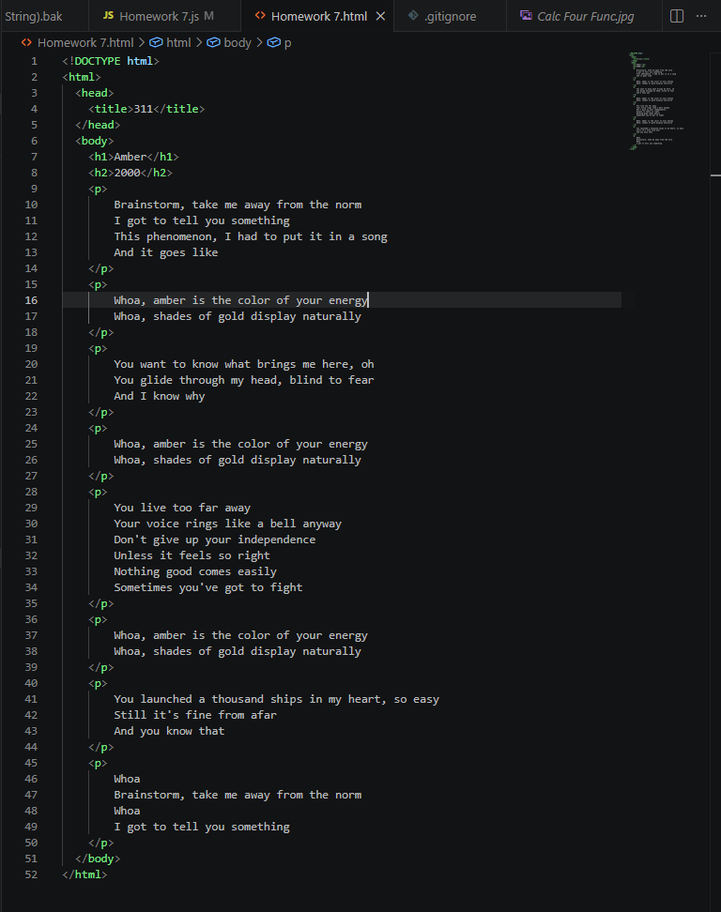

CLI program that changes every word of the same occurrence in an HTML file.
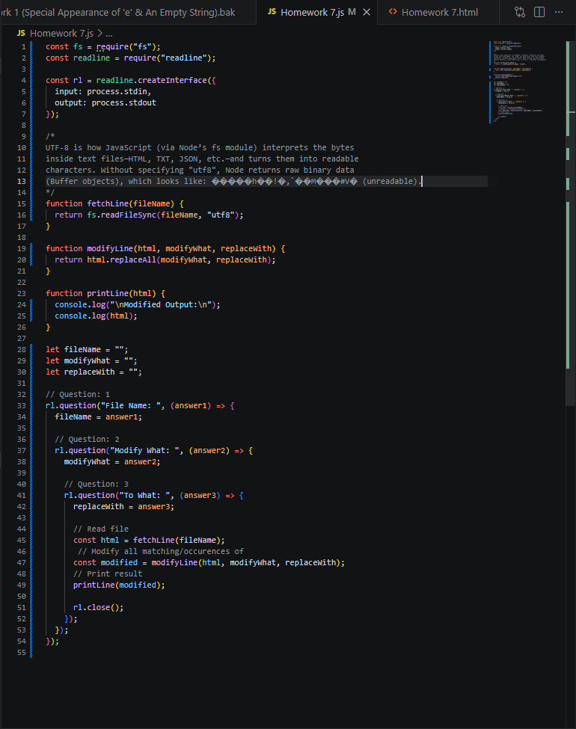

Running file w/ Output
